Can. J. Soil. Sci. Downloaded from cdnsciencepub.com by 24.84.82.223 on 12/21/24 For personal use only.



ARTICLE

Changes in soil organic matter over 18 yr in Prince Edward Island, Canada

Judith Nyiraneza, Barry Thompson, Xiaoyuan Geng, Juanxia He, Yefang Jiang, Sherry Fillmore, and Kyra Stiles

Abstract: Soil fertility decline is encountered in intensively managed low-residue systems. This long-term study (1998–2015) characterized soil organic matter (SOM) changes in the province of Prince Edward Island (PEI), Canada. The sampling locations were based on the 4 km × 4 km National Forest Inventory grid. Five sub- samples were collected within a radius of 1–6 m from the centre location at the intersecting points on the grid and at locations 100 m in each cardinal direction covering the whole province every 3 yr, for a total of six cycles. The interpolation used the regression kriging method. Means ranged from 2.8% to 3.6%, coefficients of variation ranged from 0.22 to 0.28, and residual nugget and sill values were 0.03 and 0.06, respectively. From cycle 1 to cycle 6, acreage with 2%–3% SOM increased from 10% to 73% of the total area, acreage with 3.1%–4% SOM declined from 70.6% to 24% of the total area, and acreage with >4% SOM declined from 19% to 0.8% of the total area. Areas with a history of intensive agricultural activity were associated with the lowest SOM levels (2%–3%) at the beginning of the study, and SOM levels in those areas either remained unchanged or declined (<2%) at the end of the study, suggesting a predominance of recalcitrant SOM fractions with a long- er turnover rate. This long-term study highlights the need to put in place strategies to increase levels of SOM to sustain PEI soil productivity.

*Key words:* soil organic matter, georeferenced sampling, geostatistics, regression kriging, random forest.

Résumé : Les systèmes agricoles à gestion intensive laissant peu de résidus réduisent la fertilité du sol. Cette étude de longue haleine (1998–2015) a permis de caractériser l*’*évolution de la matière organique du sol (MOS) à l*’*Île-du-Prince-Édouard, une province canadienne. Les sites échantillonnés ont été choisis d*’*après la grille 4 × 4 km de l*’*Inventaire forestier national. Cinq sous-échantillons ont été prélevés dans un rayon de un à six mètres des points d*’*intersection de la grille et à 100 m dans chaque direction cardinale, de manière à couvrir l*’*ensemble de la province tous les trois ans, durant six cycles au total. Pour l*’*interpolation, les chercheurs ont recouru au krigeage de régression. Les moyennes variaient de 2,8 % à 3,6 %, avec un coefficient de variation de 0,22 à 0,28 et des valeurs de 0,03 et 0,06 respectivement pour les pépites résiduelles et le filon- couche. Du premier au sixième cycle, la superficie du sol renfermant 2 à 3 % de MOS est passée de 10 à 73 % de la superficie totale, tandis que celle contenant 3,1 à 4 % de MOS a diminué pour passer de 70,6 à 24 %, et celle renfermant plus de 4 % de MOS est passée de 19 à 0,8 % de la superficie globale. Les endroits cultivés de façon intensive avaient été associés à la concentration la plus faible de MOS (2–3 %) au début de l*’*étude, et la situation était demeurée la même ou s*’*était détériorée (concentration < 2 %) à la fin de l*’*étude, signe que les fractions de MOS récalcitrantes prédominent, car elles mettent plus de temps à se renouveler.

Received 9 March 2017. Accepted 26 June 2017.

J. Nyiraneza* and Y. Jiang. Charlottetown Research and Development Centre, Agriculture and Agri-Food Canada, 440 University Avenue, Charlottetown, PE C1A 4N6, Canada.

B. Thompson and K. Stiles. Prince Edward Island Department of Agriculture and Fisheries, P.O. Box 2000, Charlottetown, PE C1A 7N8, Canada.

X. Geng and J. He. Agriculture and Agri-Food Canada, K.W. Neatby Building, 960 Carling Avenue, Ottawa, ON K1A 0C6, Canada.

S. Fillmore. Kentville Research and Development Centre, Agriculture and Agri-Food Canada, 32 Main Street, Kentville, NS B4N 1J5, Canada. Corresponding author: Judith Nyiraneza (email: [Judith.Nyiraneza@agr.gc.ca](mailto:Judith.Nyiraneza@agr.gc.ca)).

Abbreviations: CV, coefficient of variation; GIS, geographic information system; GPS, global positioning system; ME, mean error; NFI, National Forest Inventory; OK, ordinary kriging; PEI, Prince Edward Island; RF, random forest; RK, regression kriging; RMSE, root mean square error; SOM, soil organic matter.

*Judith Nyiraneza currently serves as an Editor; peer review and editorial decisions regarding this manuscript were handled by

B.L. Helgason.

© Her Majesty the Queen in Right of Canada as Represented by the Minister of Agriculture and Agri-Food Canada.

Can. J. Soil Sci. 97: 745–756 (2017) [dx.doi.org/10.1139/cjss-2017-0033  Published at [www.nrcresearchpress.com/cjss](http://www.nrcresearchpress.com/cjss) on 10 August 2017.](http://dx.doi.org/10.1139/cjss-2017-0033)

Cette étude de longue haleine montre qu*’*il faut mettre en place des stratégies pour augmenter la concentra- tion de MOS si on veut augmenter la productivité des sols de l*’*Île-du-Prince-Edward. [Traduit par la Rédaction]

*Mots-clés :* matière organique du sol, échantillonnage géoréférencé, géostatistique, krigeage de régression, forêt aléatoire.

# Introduction

Can. J. Soil. Sci. Downloaded from cdnsciencepub.com by 24.84.82.223 on 12/21/24 For personal use only.

Degraded soils are becoming more prevalent in many parts of the world owing to intensive land use and poor soil-conservation strategies. The depletion of soil organic matter (SOM) has often been reported in pre- vious long-term studies (Dalal and Mayer 1986; Kapkiyai et al. 1999; Nyiraneza et al. 2009). Soil organic matter is a good index of soil quality and is known to be impacted by the crops grown, the use of soil organic amendments (Grandy et al. 2002; Carter et al. 2004; Carter 2007; Nyiraneza et al. 2009, 2010), crop residue management practices (Karlen et al. 1994; Kapkiyai et al. 1999), the soil type (Prasad and Power 1997; Hu et al. 2014), and climate conditions.

Soil organic matter is a reservoir of macro- and micronutrients, and their availability is affected by microbial activity (Feichtinger et al. 2004). The bene- fits of increased SOM levels are associated with enhanced nutrient availability and soil physical prop- erties, including increased water-holding capacity. These improvements should result in high crop yields (Bauer and Black 1994; Berzsenyi et al. 2000; Önemli 2004).

Maintaining soil health has become a challenge to sustain crop production in the province of Prince Edward Island (PEI), Canada (Douglas et al. 2000). The ongoing degradation of natural resources, such as ero- sion or the siltation of watercourses, is associated with the loss of topsoil. Prince Edward Island has undulat- ing topography that contributes to the already preva- lent issue of soil erosion (Edwards et al. 1998). Potatoes (*Solanum tuberosum* L.) are an economically important crop in PEI, with the province accounting for 25% of Canadian potato production (Agriculture and Agri-Food Canada 2013). Since 2008, a 3-yr potato rotation has been mandatory under the *Agricultural Crop Rotation Act* to maintain and to improve the qual- ity of soil as well as surface water and groundwater (Commission on Nitrates in Groundwater 2008). The most commonly used potato rotation consists of bar- ley (*Hordeum vulgare* L.) underseeded with red clover (*Trifolium pratense* L.) in year 1, red clover in year 2 (incorporated into the soil in the fall), and potato in the spring in year 3. Crop residues are, in most cases, exported during the grain and legume phases, and thus, such a cropping system lacks C inputs unless it is supplemented with additional organic amendments. Potato is known to return negligible amounts of resi- dues back to the soil and is characterized by a high degree of soil disturbance.

To assess changes in soil quality, grid sampling has been increasingly used in recent years thanks to the advent of geographic information system (GIS) and global positioning system (GPS) technologies. These new technologies help integrate soil survey information and qualitative data for characterizing soil spatial variability. Sampling over time at the same site requires consistent commitment and good record keeping and facilitates the understanding of nutrient dynamics over time and how this is related to past land-use practices (Hartemink 2006). Long-term studies provide insights into temporal changes, allowing researchers to distin- guish the impact of management from that of long-term environmental trends (Robertson et al. 2008). Such stud- ies reveal direct effects in ecosystem processes that are not apparent in short-term studies (Tilman 1989) and provide a unique opportunity to directly evaluate the consequences of policy changes and address novel ques- tions (Knapp et al. 2012).

The identification of trends in SOM changes is a prerequisite for developing strategies which can help growers improve their farmland for sustainable soil productivity. The objective of this study was to describe variations in SOM over 18 yr in PEI.

# Materials and Methods

Site description

Prince Edward Island, which is located in the Gulf of St. Lawrence and is separated from the provinces of New Brunswick and Nova Scotia by the Northumberland Strait (Fig. 1), has a total area of 5665 km2, with 42% used as agricultural land (PEI Department of Agriculture and Fisheries 2015). The structural trend of the island is south- west–northeast (Whiteside 1965; van de Poll 1989), and PEI is characterized by a moderate or humid temperate climate strongly influenced by winds, air masses, and weather systems that move east from the mainland.

January and July mean temperatures are −7 and 18.7 °C,

respectively, with an annual mean precipitation of 1100 mm (25% as snow). The frost-free period varies from 100 to 160 d, allowing the cultivation of a wide variety of crops.

The geology of PEI was described by Jiang et al. (2015). The region is entirely underlain by a terrestrial sandstone formation that is 1200–1600 m in diameter, including a sequence of red beds ranging in age from Carboniferous to Middle Early Permian, and that con- sists primarily of red-brown fine- to medium-grained sandstone layers, with lesser amounts of siltstone and claystone lenses (van de Poll 1981). Soils derived from

Fig. 1. Location of Prince Edward Island (PEI) within Canada and map of PEI with county lines (A), and PEI land-use map based on the 2015 PEI crop distribution map from the Canadian annual crop inventory created by Agriculture and Agri-Food Canada (B).

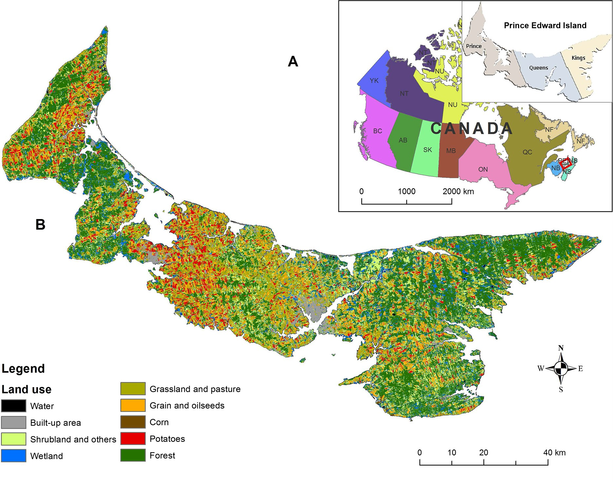

the glacial till are sandy and well drained (MacDougall et al. 1988). The island land surface is rolling: the western section of the island has a gentle relief with slopes up to 7%; the central and southeastern sections are more hilly, with slopes up to 14% and the highest elevation point (139 m above sea level); and the eastern section follows a relief lying between those of the western and central sections (MacDougall et al. 1988). The spatial variations in topography and soil appear to be correlated with the spatial distribution of the ratio of sandstone and claystone contents in the bed- rock formation.

Can. J. Soil. Sci. Downloaded from cdnsciencepub.com by 24.84.82.223 on 12/21/24 For personal use only.

Although several soil types have been identified based on variations in texture, the soils are considered rela- tively uniform across the island (Fig. 2). The dominant soil order is Podzolic/Spodosols (Fig. 2); soils in this order formed from the soft, red sandstone bedrock, are sandy, mostly red in colour, and low in bases and nutrients, and present an acid reaction (van de Poll 1989). Other soil orders, including Gleysolic/Gelisols, Luvisolic/Alfisols, and Brunisolic/Inceptisols, are also present (Fig. 2). Agriculture is concentrated in areas with fertile soils in

the eastern part of Prince County and the central part of Queens County (Figs. 1A, 1B). Smaller tracts of culti- vable soil are located in the western part of Prince County and in Kings County (MacDougall et al. 1988). The predominant crops are potato, grain, and forage (Fig. 1B) and are rotated on a 3 yr basis. Recently, an increased acreage under oilseed crops such as canola and soybean has been observed.

Sampling procedure, sample handling, and analyses

The sampling procedure was described in detail by Douglas et al. (2000). Briefly, intersecting points (i.e., nodes) on a 4 km × 4 km National Forest Inventory (NFI) grid system (Canadian Forest Inventory Committee 1998) were considered potential sampling locations, and a total of 232 agricultural-land sampling locations were identified. Soil samples (1–4 L) were col- lected, using an Edelman soil auger, in the spring before tillage. The sampling was performed at the actual inter- secting point on the grid and at locations 100 m north, south, east, and west of the intersecting point, provided that the potential sampling area was agricultural land.

Fig. 2. Dominant soil orders in Prince Edward Island. Source: Xiaoyuan Geng.

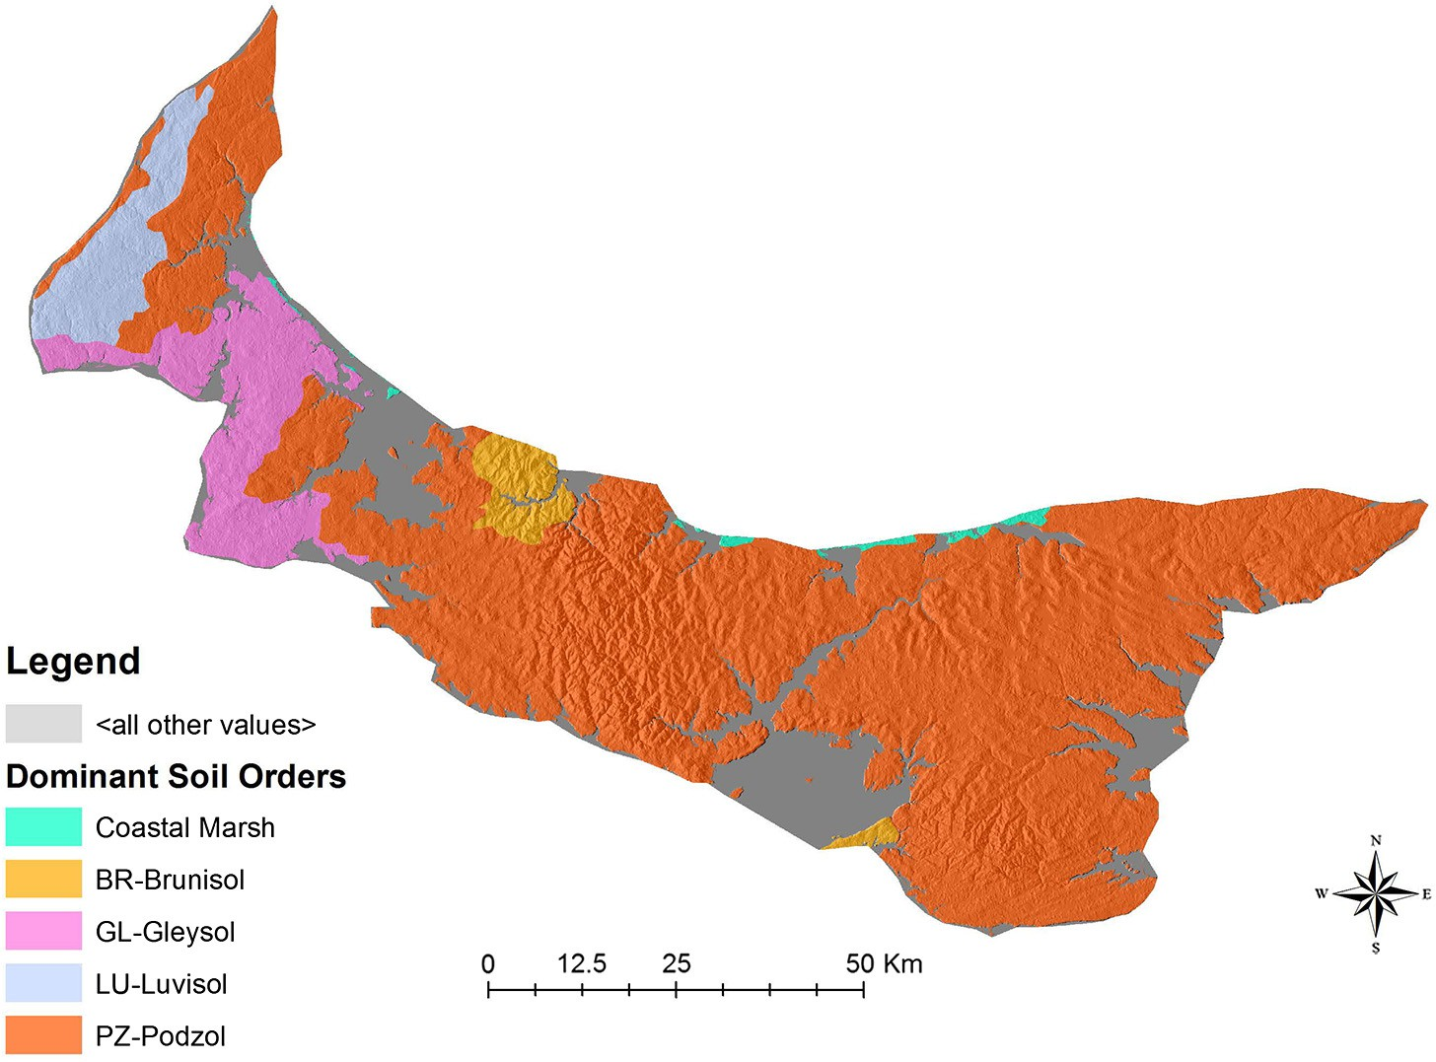

The number of sampled sites changed across years because sites were lost as a result of changes in land use following the conversion of agricultural land to a cemetery, residential, or commercial areas, or other uses. A composite soil sample was collected at a depth of 17 cm at the centre location and at four locations within a radius of 1–6 m. The samples were air-dried, passed through a 2 mm sieve, and ground. The coordi- nates (northings and eastings) of each sampling site were determined using a GPS unit. A GIS was used to present the sampling sites on maps with a scale of 1:100 000, and the maps and a GPS unit were used to locate the sampling nodes. One third of sampling sites across the province were sampled every year, so that all sampling sites province-wide were fully covered every 3 yr. The first third of the samples was taken in spring 1998, the second third in spring 1999, and the final third in spring 2000. Georeferenced samples were taken at each site once every 3 yr from 1998 to 2015, for a total of six cycles.

Can. J. Soil. Sci. Downloaded from cdnsciencepub.com by 24.84.82.223 on 12/21/24 For personal use only.

The dry-combustion method was used on the ground samples to determine total organic C using an auto- mated resistance furnace (CNS-2000; LECO), and an infrared detector was used to quantify CO2 (Miller et al. 1997).

Statistical analyses

Soil organic matter levels were interpolated using the regression kriging (RK) method, which is a combination of random forest (RF) regression and ordinary kriging (OK) of RF regression residuals. Figure 3 shows the

major step followed in this study. The soil properties for each cycle were first inferred using RF with the training data, and then the spatial autocorrelation of RF residuals on the testing data was examined. If the RF residuals at the testing data locations presented spa- tial autocorrelation, OK was used to interpolate the residuals; the final prediction result was the addition of the RF regression prediction and kriging of residuals. This interpolation approach is called RK (Odeha et al. 1994). If no spatial autocorrelation was observed in the RF regression residuals, OK was not performed, and the RF regression result was the final result. Samples collected at the intersecting points on the NFI grid were used as training data to construct RF models. The sam- ples collected at locations 100 m north, south, east, and west of the intersecting points on the NFI grid (i.e., the training data used in this study) were used as testing data to evaluate the performance of RF in the interpolation of soil properties. The basic statistics of the training and testing data used in each of the six cycles are listed in Table 1.

In this study, the training data sets showed a skewed distribution, which could also reflect on RF regression residuals. To reduce the effect of outliers in the regres- sion process, to obtain reliable kriging results for the RF regression residuals, and to keep the process consistent, the training and testing data were log- transformed before RF was implemented. The normal- ity test on the training and testing data for each cycle was performed using the Shapiro–Wilk*’*s test (Royston 1982).

Fig. 3. Data flow chart showing the major steps used in the study. DEM, digital elevation model; TWI, topographic wetness index; MRVBF, multiresolution index of valley bottom flatness.

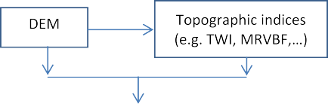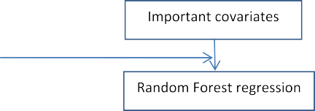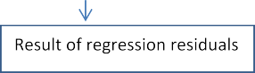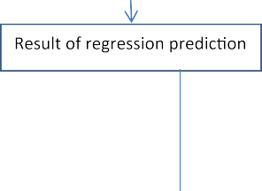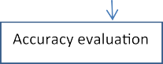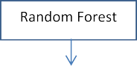

Table 1. Basic statistics [count, minimum, maximum, mean, and coefficient of variation (CV)] of the training and testing data used in each cycle of soil organic matter sampling (unit, %).

Training data Testing data

|  |  |  |  |  |  |  |  |  |  |  |  |
| --- | --- | --- | --- | --- | --- | --- | --- | --- | --- | --- | --- |
| Cycles | Count | Min | Max | Mean | CV |  | Count | Min | Max | Mean | CV |
| 1 | 123 | 1.78 | 6.55 | 3.48 | 0.223 |  | 501 | 1.69 | 7.87 | 3.59 | 0.253 |
| 2 | 121 | 1.89 | 5.47 | 3.28 | 0.218 |  | 494 | 1.39 | 7.8 | 3.37 | 0.250 |
| 3 | 120 | 1.55 | 5.75 | 3.09 | 0.232 |  | 473 | 1.37 | 6.04 | 3.15 | 0.238 |
| 4 | 105 | 1.74 | 5.44 | 2.91 | 0.232 |  | 436 | 1.29 | 6.33 | 2.95 | 0.260 |
| 5 | 58 | 1.72 | 7.45 | 2.98 | 0.298 |  | 243 | 1.45 | 6.48 | 3.014 | 0.251 |
| 6 | 100 | 1.53 | 6.02 | 2.90 | 0.251 |  | 392 | 1.1 | 6.5 | 2.827 | 0.256 |

Regression residuals were calculated at the testing data locations. The Shapiro–Wilk*’*s test was performed to assess the normality of the residuals. The test indi- cated that all the residuals were normally distributed. Variogram analysis on the calculated regression resid- uals was conducted. If the residuals showed spatial cor- relation, a theoretical semivariogram was fitted, including range, partial sill, and nugget values. Spatial correlation of the SOM regression residuals for all the six cycles was found. Thus, the final prediction result for SOM is the sum of the RF regression result and the kriging result of the regression residuals. Table 2 shows the details of the fitted semivariogram parameters for the SOM regression residuals.

Can. J. Soil. Sci. Downloaded from cdnsciencepub.com by 24.84.82.223 on 12/21/24 For personal use only.

Environmental variables used as covariates

In this study, various topographic indices derived from a digital elevation model were used as environmen- tal covariates (i.e., predictors) to infer SOM. The digital elevation model data set downloaded from Natural Resources Canada was first resampled to 30 m using the bilinear interpolation method and projected to the Universal Transverse Mercator coordinate system (zone 20 N) with the WGS 1984 datum. The topographic indices were calculated using the SAGA GIS software package (Conrad et al. 2015). The important covariates were iden- tified using RF. The covariates used in the RF regression process were flow accumulation (Goodchild et al. 1996), convergence index (Köthe and Lehmeier 1996),

Table 2. Fitted semivariogram parameters and model performance assessment.

RF model performance

Semivariogram parameters assessment

|  |  |  |  |  |  |  |  |  |
| --- | --- | --- | --- | --- | --- | --- | --- | --- |
| Cycles | Model | Nugget | Partial sill | Sill | Range (m) |  | ME | RMSE |
| 1 | Spherical | 0.03 | 0.030 | 0.06 | 10 068 |  | 0.019 | 0.258 |
| 2 | Spherical | 0.03 | 0.031 | 0.06 | 8 851 |  | 0.020 | 0.254 |
| 3 | Spherical | 0.03 | 0.031 | 0.06 | 7 553 |  | 0.017 | 0.251 |
| 4 | Spherical | 0.03 | 0.036 | 0.06 | 10 187 |  | 0.004 | 0.264 |
| 5 | Spherical | 0.03 | 0.028 | 0.06 | 8 331 |  | 0.024 | 0.270 |
| 6 | Spherical | 0.03 | 0.034 | 0.06 | 7 648 |  | 0.010 | 0.271 |

Note: RF, random forest; ME, mean error; RMSE, root mean square error.

multiresolution index of valley bottom flatness (Gallant and Dowling 2003), plan curvature (de Smith et al. 2015), slope gradient, and topographic wetness index (Sørensen et al. 2006).

Accuracy evaluation

The performance of the RF regression models for SOM was evaluated by calculating the mean error (ME) and root mean square error (RMSE) on the testing data (listed in Table 1), by means of the following formulas:

ME = 1 X*m* *z*(*s* ) − *z*ˆ(*s* )

*m*

*i*=1

*j*

*j*

Cambardella and Karlen 1999). The geostatistical range is the distance over which variables are spatially autocor- related. As shown in Table 2, the major range values ranged from 7.5 to 10 km.

Mean error was used to assess the degree of bias of RF, and RMSE was used to evaluate the precision of RF. The ideal values of ME and RMSE are zero. All the ME values are close to zero in the study, reflecting the high predic- tion capacity of semivariogram models (Table 2). The pre- dicted SOM values present a positive bias (i.e., positive ME values). The RMSE of SOM is approximately 20% of

the average SOM sample values in the log-transformed

rﬃ1ﬃﬃﬃﬃXﬃﬃﬃﬃﬃﬃﬃﬃﬃﬃﬃﬃ ﬃﬃﬃﬃﬃﬃﬃﬃﬃﬃﬃﬃﬃﬃﬃﬃﬃﬃﬃﬃﬃﬃﬃﬃ ﬃﬃﬃ

space.

RMSE = *m*

*m*

*i*=1

*z*(*sj*) − *z*ˆ(*sj*) 2

Predictions of SOM

The interpolation was done without masking nonagri-

where *m* is the number of testing points, *z*(*sj*) is the observed value at testing point *sj*, and *z*ˆ(*sj*) is the pre- dicted value at testing point *sj*.

Can. J. Soil. Sci. Downloaded from cdnsciencepub.com by 24.84.82.223 on 12/21/24 For personal use only.

# Results and Discussion

Descriptive statistics

Descriptive statistics [minimum, maximum, mean, and coefficient of variation (CV)] for each cycle are sum- marized in Table 1. Means ranged from 2.8% to 3.6%, and CVs, which indicate how uniformly the values are distributed relative to the mean (Wilding and Drees 1983; Wang et al. 2009), ranged from 22% to 30%. Values of CV from 16% to 35% indicate moderate variability (Wilding and Drees 1983; Nielsen and Bouma 1985). Variations in soil characteristics are often attributed to differences in parent material, pedogenesis, and land use (Shi et al. 2008), and moderate variability of SOM reflects low variation in soil type (Fig. 2).

Semivariograms and spatial autocorrelation

Semivariogram modelling and associated parameters are summarized in Table 2. The residual nugget/sill ratio has been used to describe spatial structural variation for a regionalized variable and for a given soil property (Cambardella et al. 1994). The nugget/sill ratio of 50% for SOM (Table 2) indicates moderate spatial dependence throughout the six cycles (Cambardella et al. 1994;

cultural land (i.e., water, exposed land, shrub, wetland, and forest), as the maps were of better quality and the outcomes of the study were unchanged with or without excluding the nonagricultural land. The RF method offers multiple advantages: it does not assume a tight linear relationship between the target properties and environment covariates, it can be used to identify impor- tant covariates in a regression/classification process, it allows the handling of low-density samples that may not be suitable for OK and co-kriging, and it allows the consideration of categorical covariates such as parent materials.

The predicted SOM values were grouped into four classes: <2%; 2%–3%; 3.1%–4%; and >4% (Table 3; Fig. 4). It was observed that areas in the high range of SOM classes (3.1%–4% and >4%) declined from the beginning of the study to the end, whereas areas in the 2%–3% SOM range increased. From cycle 1 to cycle 6, the per- centage of the total land area with >4% SOM declined from 19.2% to 0.8%, and the percentage of the total land area with 3.1%–4% SOM declined from 71% to 24% (Table 3; Fig. 4). Conversely, the percentage of the total land area with 2%–3% SOM increased from 10% to 73% from cycle 1 to cycle 6, respectively.

The dominant soil texture in PEI is sandy, which explains the low SOM ranges. The spatial distribution of

Table 3. Areas (numerator; unit, ha) and percentages (denominator) of soil organic matter (SOM) by different classes for each cycle.

|  |  |  |  |  |  |  |
| --- | --- | --- | --- | --- | --- | --- |
| SOM classes | Cycle 1 | Cycle 2 | Cycle 3 | Cycle 4 | Cycle 5 | Cycle 6 |
| 1 (<2) | 19/0 | 84/0 | 1 203/0.2 | 7 404/1.3 | 2 908/0.5 | 11 522/2 |
| 2 (2%–3%) | 58 996/10.2 | 115 170/19.8 | 246 486/42.5 | 380 211/65.5 | 353 977/61 | 424 387/73.1 |
| 3 (3.1%–4%) | 409 880/70.6 | 416 828/71.8 | 322 287/55.5 | 184 636/31.8 | 204 100/35.2 | 139 981/24.1 |
| 4 (>4%) | 111 629/19.2 | 48 442/8.3 | 10 548/1.8 | 8 273/1.4 | 19 539/3.4 | 4 633/0.8 |

Fig. 4. Predicted soil organic matter (SOM) levels based on the random forest method. The circles indicate the area of low agricultural intensity and with the highest SOM levels from cycle 1 to cycle 6. Data source: PEI Department of Agriculture and Fisheries.

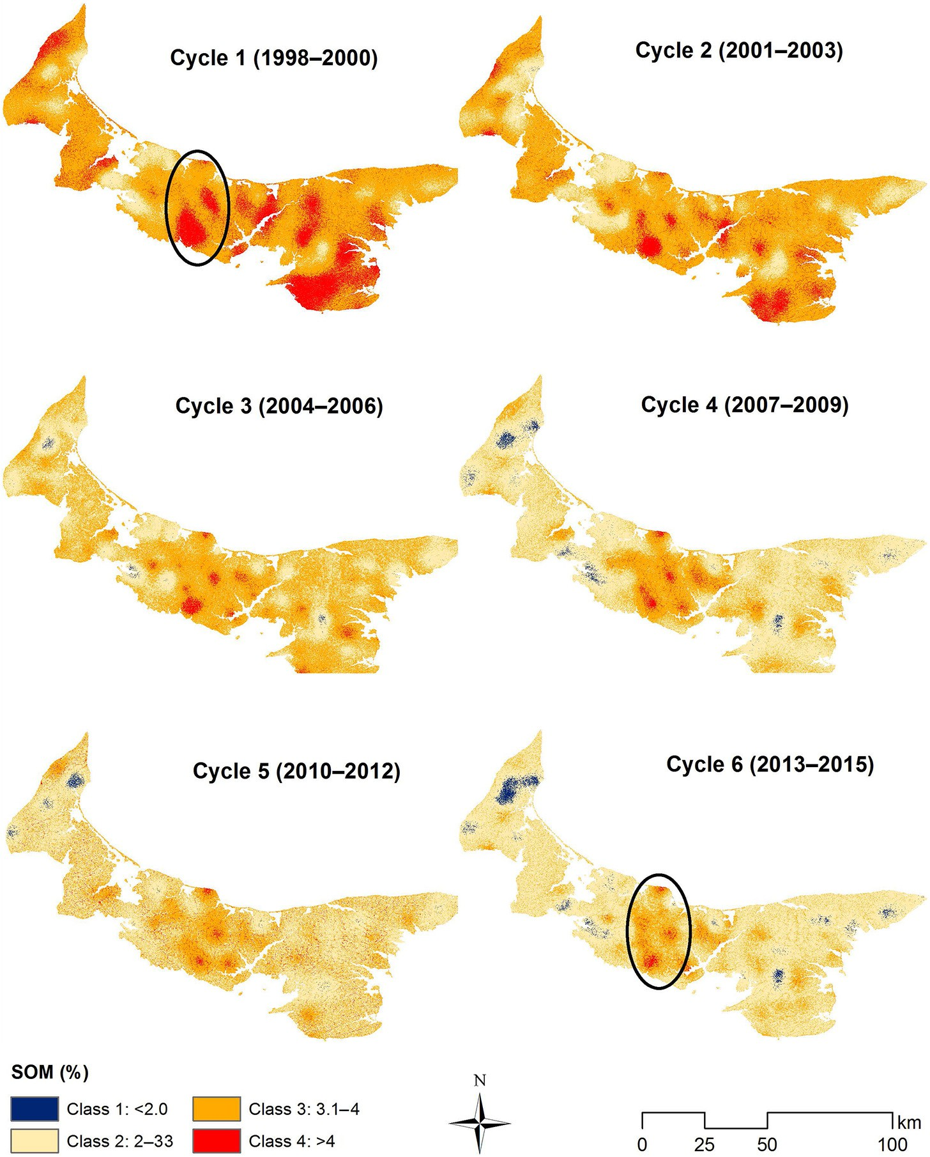

SOM is controlled by both intrinsic and extrinsic factors. The majority of PEI soils were derived from the tills origi- nating from the underlying red sandstone bedrock. It is well known that soils with clayey or loamy textures have

Can. J. Soil. Sci. Downloaded from cdnsciencepub.com by 24.84.82.223 on 12/21/24 For personal use only.

higher levels of SOM than sandy-textured soils do (Prasad and Power 1997; Hu et al. 2014).

Our results showing SOM decline in PEI are in accordance with those of previous long-term studies

(Dalal and Mayer 1986; Kapkiyai et al. 1999; Nyiraneza et al. 2009). In a study conducted in Quebec, Canada, on a clay loam soil, Nyiraneza et al. (2009) reported that soil organic C declined by 0.25 g C kg−1 yr−1 after 28 yr of rotating silage corn and grain, with straw removed dur-

Can. J. Soil. Sci. Downloaded from cdnsciencepub.com by 24.84.82.223 on 12/21/24 For personal use only.

ing the grain phase. The declining SOM in PEI can be attributed in part to low residue return and intensive farming operations. Factors such as frequent soil tillage help accelerate SOM oxidation, coupled with the risk of soil erosion due to the nature of coarse-textured soils and to a sloping landscape with slopes up to 12° (Edwards et al. 1998). Additional factors such as high rates of precipitation in the fall and spring (averaging 1100 mm) contribute to the increased risk of soil ero- sion when the soil is left bare, causing SOM and nutrient losses along with sediment transport. Edwards et al. (1998) measured sediment deposition in the spring in a study conducted over 80 site-years in PEI and reported average sediment deposition amounts

of 13.3, 0.4, and 1.6 t ha−1 after potatoes, forage, and grain, respectively, for a total of 16 t ha−1 every 3 yr. Cool winter cover cropping would help hold the soil in

place and thus mitigate soil erosion while adding organic matter to the soil, but the cold and short grow- ing season and a late-maturing processing potato vari- ety (Russet Burbank) limits catch-crop growth after the potato harvest (Zebarth et al. 2015). The SOM decline in PEI can also be explained by additional changes in crop- ping systems, such as the declining number of livestock operations, the clearing of forest land acreage in western PEI, and the significant increase in soybean acreage in recent years (B.L. Thompson, 2016, personal communication, PEI Department of Agriculture and Fisheries, Charlottetown, PE). Between 2005 and 2015, total cattle and hog numbers decreased by 24% and 54%, respectively (PEI Department of Agriculture and Fisheries 2016). During the same period, soybean- seeded acreage increased by 447% across the island (PEI Department of Agriculture and Fisheries 2016); soy- bean is another low-residue crop that is not expected to increase C inputs.

Changes in SOM

Positive and negative SOM changes from one class to another were observed (Table 4; Fig. 5). Most of the area (56% of the total land) was characterized by a shift from class 3 (3.1%–4%) to class 2 (2%–3%), which implies an

overall decline of approximately 1% SOM in 18 yr, corre- sponding to −0.05% SOM yr−1. That decline is faster than the decline reported by Nyiraneza et al. (2009) in a clay

loam soil over 28 yr, a discrepancy that can be explained by the difference in soil types. Changes from class 4 (>4%) to class 2 (2%–3%) and from class 4 (>4%)

to class 3 (3.1%–4%) occurred in 8% and 11% of the total area, respectively (Table 4; Fig. 5), including acreage that showed the highest SOM levels (>4%) at the begin- ning of the study (Fig. 4), with patches in Prince

Table 4. Areas (numerator; unit, ha) and percentages (denominator) of changes in soil organic matter classes between cycle 1 and cycle 6.

|  |  |
| --- | --- |
|  | Cycles 1–6 |
| Unchanged | 131 782/22.7 |
| From class 1 to class 2 | 1/0 |
| From class 2 to class 1 | 8 144/1.4 |
| From class 2 to class 3 | 495/0.1 |
| From class 2 to class 4 | 0/0 |
| From class 3 to class 1 | 3 350/0.6 |
| From class 3 to class 2 | 328 618/56.6 |
| From class 3 to class 4 | 570/0.1 |
| From class 4 to class 1 | 10/0 |
| From class 4 to class 2 | 45 411/7.8 |
| From class 4 to class 3 | 62 144/10.7 |

Note: Class 1, <2%; class 2, 2%–3%; class 3,

3.1%–4%; class 4, >4%.

County (southeastern, western, and central parts), in Queens County, and in the western part of Kings County.

In some areas (22% of the total land), it was observed that SOM remained unchanged over the study period (Table 4; Fig. 5). The first category corresponded to the areas with the lowest SOM levels at the beginning of the study (class 2, 2%–3% SOM; Fig. 4, cycle 1). This cat- egory also corresponded to the areas with intensive agricultural activity (Fig. 1B) and dominated by the main crops grown in PEI, namely, potato, grain, oilseeds, and forage, with residues exported mostly during the grain and forage phases. Even though we do not have infor- mation on when these areas with unchanged SOM over the course of the study had been brought under cultiva- tion, their lower SOM levels at the beginning of the study suggest that they have been cultivated for many years. Soil organic matter continued to decline in these areas, as shown by spots with SOM levels below 2.0% at the end of the sixth cycle (Fig. 4, cycle 6). The trend in SOM also suggests a predominance of recalcitrant SOM fractions. Two main factors control soil C storage: the amount and quality of C inputs and the rate of C decom- position. Within the area of intensive cultivation where low-residue cropping systems have been rotated, C inputs are low and the decomposition rate is enhanced by intensive and frequent tillage operations, especially during the potato phase. Upon cultivation, the labile SOM pool is greatly depleted (Cambardella and Elliott 1992; Six et al. 1999; Solomon et al. 2000), and protected C is lost from macroaggregates. Frequent cultivation of light soils enhances their susceptibility to soil erosion and the subsequent loss of topsoil and fine particles. Therefore, the labile SOM pool decreases with time at the expense of the stabilized pool, which is known to have a longer turnover and residence time. The most commonly cited mechanisms by which SOM can be

Fig. 5. Changes in soil organic matter (SOM) between cycle 1 and cycle 6. Class 1, <2%; class 2, 2%–3%; class 3, 3.1%–4%; class 4, >4%. Data source: PEI Department of Agriculture and Fisheries.

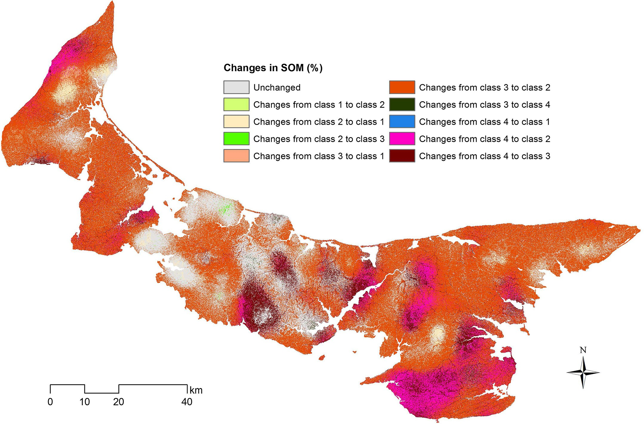

protected against mineralization include physical pro- tection via microaggregation, strong association of SOM with mineral particles, and biochemical stabiliza- tion through the formation of recalcitrant materials (Six et al. 2002). For instance, it was reported that SOM in finer particles such as clay and silt is older (Quideau et al. 2001; Eusterhues et al. 2003) and has a longer turn- over rate (Ludwig et al. 2003). Soil organic matter can be also stabilized through interactions among cations on the surface of soil particles with permanent charges and organic molecules at pH ranging from 5 to 6 (Oades 1989), with stronger bonds observed for Fe3+ and Al3+ than for Ca2+ and Mg2+ (Lützow et al. 2006). The first two cations are known to be predominant in Podzolic soils.

Can. J. Soil. Sci. Downloaded from cdnsciencepub.com by 24.84.82.223 on 12/21/24 For personal use only.

There is another category in which it was observed that SOM remained unchanged over the period of the study: the area of low agricultural intensity and with the highest SOM levels from cycle 1 to cycle 6 (Figs. 1B and 4, circled area). This area also includes spots showing declining SOM, from class 4 to class 2 and from class 4 to class 3, which represent land that had been recently con- verted to agriculture from either forest or forage.

Maintaining adequate SOM in a soil is essential for sustainable production systems. The results from this long-term study show that the current rotation systems in PEI are not sufficient to maintain SOM and that further efforts are needed to reverse this trend toward declining SOM. Organic amendments such as compost and manure have been reported to increase soil nutrients and improve soil productivity in low- residue cropping systems (Grandy et al. 2002; Carter et al. 2004; Carter 2007; Nyiraneza et al. 2009). Maintaining or adding crop residues enables the soil to resist wind and water erosion and helps the soil retain more water and essential plant nutrients (Karlen et al. 1994). Crop residue retention was previously reported to offset SOM decline (Kapkiyai et al. 1999). In the same study, manure application in combination with maize stove retention also reduced SOM decline by 49% (Kapkiyai et al. 1999). Growing perennial forages was found to increase SOM (Nyiraneza et al. 2009, 2010). To improve soil and agroecosystem health and reverse SOM decline in PEI, growers could consider incorporating straw and forage biomass into soils in the short term. In the long term, accurate and reliable means of

achieving those goals need to be put in place through the adoption of a powerful combination of best man- agement practices, such as new rotation systems that increase soil C inputs, the incorporation of manure and compost, the intensive use of cover cropping, con- servation tillage, and crop diversification.

Can. J. Soil. Sci. Downloaded from cdnsciencepub.com by 24.84.82.223 on 12/21/24 For personal use only.

# Conclusions

This long-term study was undertaken to examine changes in SOM across the province of PEI. Regression kriging was an efficient method that allowed the integra- tion of covariates. The study revealed that the total land area with SOM levels in the high range is decreasing over time, indicating continuous soil degradation. Soil organic matter remained unchanged or declined at lev- els <2% in the areas with a long history of intensive culti- vation that were associated with the lowest levels of SOM at the beginning of the study, suggesting a predomi- nance of recalcitrant SOM fractions. Strategies to build SOM should focus first on these areas, which correspond to PEI*’*s potato belt. Unchanged SOM levels were also observed in areas characterized by low agricultural intensity, which maintained the highest SOM levels over the period of the study. Maintaining high levels of SOM is of paramount importance for sustaining crop produc- tion systems. Strategies to increase soil C inputs through returning crop residues, incorporating manures and composts, making intensive use of cover cropping, implementing reduced tillage, adopting best manage- ment practices for soil conservation, and promoting crop diversifications are needed to sustain the health of PEI agroecosystems. The results from this study confirm that, under low-residue cropping systems coupled with intensive tillage, SOM is expected to decrease over time unless a regular C input is supplied or the tillage inten- sity is reduced.

# Acknowledgements

We are grateful to the staff of the PEI Department of Agriculture and Fisheries for sample and data collection and for funding resources for sample analyses. The assis- tance of Chad Cordes with geostatistical analyses at the early stage of data analysis is acknowledged with great appreciation. Special gratitude is extended to Dr. John MacLeod for providing comments on the early version of the manuscript.

# References

Agriculture and Agri-Food Canada. 2013. Potato market infor- mation review 2012–2013. [Online]. Available from [http://](http://publications.gc.ca/collections/collection_2015/aac-aafc/A71-32-2013-eng.pdf) [publications.gc.ca/collections/collection_2015/aac-aafc/](http://publications.gc.ca/collections/collection_2015/aac-aafc/A71-32-2013-eng.pdf) [A71-32-2013-eng.pdf](http://publications.gc.ca/collections/collection_2015/aac-aafc/A71-32-2013-eng.pdf) [15 June 2016].

Bauer, A., and Black, A.L. 1994. Quantification of the effect of soil organic matter content on soil productivity. Soil Sci. Soc. Am. J. 58: 185–193. doi:[10.2136/sssaj1994.](http://dx.doi.org/10.2136/sssaj1994.03615995005800010027x) [03615995005800010027x](http://dx.doi.org/10.2136/sssaj1994.03615995005800010027x).

Berzsenyi, Z., Győrffy, B., and Lap, D. 2000. Effect of crop rota- tion and fertilisation on maize and wheat yields and yield

stability in a long-term experiment. Eur. J. Agron. 13: 225–244. doi:[10.1016/S1161-0301(00)00076-9](http://dx.doi.org/10.1016/S1161-0301(00)00076-9).

Cambardella, C.A., and Elliott, E.T. 1992. Particulate soil organic- matter changes across a grassland cultivation sequence. Soil Sci. Soc. Am. J. 56: 777–783. doi:[10.2136/sssaj1992.0361599500](http://dx.doi.org/10.2136/sssaj1992.03615995005600030017x) [5600030017x](http://dx.doi.org/10.2136/sssaj1992.03615995005600030017x).

Cambardella, C.A., and Karlen, D.L. 1999. Spatial analysis of soil fertility parameters. Precis. Agric. 1: 5–14. doi:10.1023/A: 1009925919134.

Cambardella, C.A., Moorman, T.B., Novak, J.M., Parkin, T.B., Karlen, D.L., Turco, R.F., and Konopka, A.E. 1994. Field-scale variability of soil properties in central Iowa soils. Soil Sci. Soc. Am. J. 58: 1501–1511. doi:[10.2136/sssaj1994.036159950](http://dx.doi.org/10.2136/sssaj1994.03615995005800050033x) [05800050033x](http://dx.doi.org/10.2136/sssaj1994.03615995005800050033x).

Canadian Forest Inventory Committee. 1998. Developing the national forest inventory design. Canadian Forest Inventory Committee, Pacific Forestry Centre, Canadian Forest Service, Victoria, BC, Canada.

Carter, M.R. 2007. Long-term influence of compost on available water capacity of a fine sandy loam in a potato rotation. Can. J. Soil Sci. 87: 535–539. doi:[10.4141/CJSS06042](http://dx.doi.org/10.4141/CJSS06042).

Carter, M.R., Sanderson, J.B., and MacLeod, J.A. 2004. Influence of compost on the physical properties and organic matter fractions of a fine sandy loam throughout the cycle of a potato rotation. Can. J. Soil Sci. 84: 211–218. doi:[10.4141/](http://dx.doi.org/10.4141/S03-058) [S03-058](http://dx.doi.org/10.4141/S03-058).

Commission on Nitrates in Groundwater. 2008. The report of the Commission of Nitrates in Groundwater. Government of Prince Edward Island, Charlottetown, PE, Canada. [Online]. Available from [https://www.princeedwardisland.ca/](https://www.princeedwardisland.ca/en/publication/report-commission-nitrates-groundwater) [en/publication/report-commission-nitrates-groundwater](https://www.princeedwardisland.ca/en/publication/report-commission-nitrates-groundwater) [6

Mar. 2017].

Conrad, O., Bechtel, B., Bock, M., Dietrich, H., Fischer, E., Gerlitz, L., Wehberg, J., Wichmann, V., and Böhner, J. 2015. System for automated geoscientific analyses (SAGA) v. 2.1.4. Geosci. Model Dev. Discuss. 8: 2271–2312. [Online]. Available from [http://www.geosci-model-dev-discuss.net/8/2271/2015/](http://www.geosci-model-dev-discuss.net/8/2271/2015/gmdd-8-2271-2015.pdf) [gmdd-8-2271-2015.pdf](http://www.geosci-model-dev-discuss.net/8/2271/2015/gmdd-8-2271-2015.pdf) [5 Mar. 2017].

Dalal, R.C., and Mayer, R.J. 1986. Long term trends in fertility of soils under continuous cultivation and cereal cropping in southern Queensland. II. Total organic carbon and its rate of loss from the soil profile. Austr. J. Soil Res. 24: 281–292. doi:[10.1071/SR9860281](http://dx.doi.org/10.1071/SR9860281).

de Smith, M.J., Goodchild, M.F., and Longley, P.A. 2015. Geospatial analysis: a comprehensive guide to principles, techniques and software tools. 2nd ed. Winchelsea Press, Winchelsea, UK.

Douglas, B.W., MacLeod, J.A., Mellish, T.M., Glen, W.M.,

Thompson, B.L., DeHaan, K.R., Sturz, A.V., Carter, M.R., and Brimacombe, M.B. 2000. A method for measuring Prince Edward Island soil quality. Commun. Soil Sci. Plant Anal. 31: 1837–1845. doi:[10.1080/00103620009370541](http://dx.doi.org/10.1080/00103620009370541).

Edwards, L., Richter, G., Bernsdorf, B., Schmidt, R.-G., and Burney, J. 1998. Measurement of rill erosion by snowmelt on potato fields under rotation in Prince Edward Island (Canada). Can. J. Soil Sci. 78: 449–458. doi:[10.4141/](http://dx.doi.org/10.4141/S97-053) [S97-053](http://dx.doi.org/10.4141/S97-053).

Eusterhues, K., Rumpel, C., Kleber, M., and Kögel-Knabner, I. 2003. Stabilisation of soil organic matter by interactions with minerals as revealed by mineral dissolution and oxidative degradation. Org. Geochem. 34: 1591–1600. doi:[10.1016/j.](http://dx.doi.org/10.1016/j.orggeochem.2003.08.007) [orggeochem.2003.08.007](http://dx.doi.org/10.1016/j.orggeochem.2003.08.007).

Feichtinger, F., Erhart, E., and Hartl, W. 2004. Net N-minerali- sation related to soil organic matter pools. Plant Soil Environ. 50: 273–276.

Gallant, J.C., and Dowling, T.I. 2003. A multiresolution index of valley bottom flatness for mapping depositional areas. Water Resour. Res. 39: 1347. doi:[10.1029/2002WR001426](http://dx.doi.org/10.1029/2002WR001426).

Goodchild, M.F., Steyaert, L.T., Parks, B.O., Johnston, C., Maidment, D., Crane, M., and Glendinning, S. (eds.). 1996. GIS and environmental modeling: progress and research issues. John Wiley and Sons, Inc., New York, NY, USA.

Can. J. Soil. Sci. Downloaded from cdnsciencepub.com by 24.84.82.223 on 12/21/24 For personal use only.

Grandy, A.S., Porter, G.A., and Erich, M.S. 2002. Organic amend- ment and rotation crop effects on the recovery of soil organic matter and aggregation in potato cropping systems. Soil Sci. Soc. Am. J. 66: 1311–1319. doi:[10.2136/sssaj2002.1311](http://dx.doi.org/10.2136/sssaj2002.1311).

Hartemink, A.E. 2006. Assessing soil fertility decline in the tropics using soil chemical data. Adv. Agron. 89: 179–225. doi:[10.1016/S0065-2113(05)89004-2](http://dx.doi.org/10.1016/S0065-2113(05)89004-2).

Hu, K., Wang, S., Li, H., Huang, F., and Li, B. 2014. Spatial scaling effects on variability of soil organic matter and total nitrogen in suburban Beijing. Geoderma, 226–227: 54–63. doi:[10.1016/](http://dx.doi.org/10.1016/j.geoderma.2014.03.001) [j.geoderma.2014.03.001](http://dx.doi.org/10.1016/j.geoderma.2014.03.001).

Jiang, Y., Nishimura, P., van den Heuvel, M.R., MacQuarrie, K.T.B., Crane, C.S., Xing, Z., Raymond, B.G., and Thompson, B.L. 2015. Modeling land-based nitrogen loads from groundwater- dominated agricultural watersheds to estuaries to inform nutrient reduction planning. J. Hydrol. 529: 213–230. doi:[10.1016/j.jhydrol.2015.07.033](http://dx.doi.org/10.1016/j.jhydrol.2015.07.033).

Kapkiyai, J.J., Karanja, N.K., Quereshi, J.N., Smithson, P.C., and Woomer, P.L. 1999. Soil organic matter and nutrient dynam- ics in a Kenyan nitisol under long-term fertilizer and organic input management. Soil Biol. Biochem. 31: 1773–1782. doi:[10.1016/S0038-0717(99)00088-7](http://dx.doi.org/10.1016/S0038-0717(99)00088-7).

Karlen, D.L., Wollenhaupt, N.C., Erbach, D.C., Berry, E.C., Swan, J.B., Eash, N.S., and Jordahl, J.L. 1994. Long-term tillage effects on soil quality. Soil Tillage Res. 32: 313–327. doi:[10.1016/0167-1987(94)00427-G](http://dx.doi.org/10.1016/0167-1987(94)00427-G).

Knapp, A.K., Smith, M.D., Hobbie, S.E., Collins, S.L., Fahey, T.J.,

Hansen, G.J.A., Landis, D.A., La Pierre, K.J., Melillo, J.M., Seastedt, T.R., Shaver, G.R., and Webster, J.R. 2012. Past, present, and future roles of long-term experiments in the LTER Network. BioScience, 62: 377–389. doi:[10.1525/bio.](http://dx.doi.org/10.1525/bio.2012.62.4.9)

[2012.62.4.9](http://dx.doi.org/10.1525/bio.2012.62.4.9).

Köthe, R., and Lehmeier, F. 1996. SARA–System zur Automatischen Relief-Analyse. User manual [in German]. 2nd ed. Department of Geography, University of Göttingen, Göttingen, Germany.

Ludwig, B., John, B., Ellerbrock, R., Kaiser, M., and Flessa, H. 2003. Stabilization of carbon from maize in a sandy soil in a long-term experiment. Eur. J. Soil Sci. 54: 117–126. doi:[10.](http://dx.doi.org/10.1046/j.1365-2389.2003.00496.x) [1046/j.1365-2389.2003.00496.x](http://dx.doi.org/10.1046/j.1365-2389.2003.00496.x).

Lützow, M.V., Kögel-Knabner, I., Ekschmitt, K., Matzner, E., Guggenberger, G., Marschner, B., and Flessa, H. 2006. Stabilization of organic matter in temperate soils: mecha- nisms and their relevance under different soil conditions — a review. Eur. J. Soil Sci. 57: 426–445. doi:[10.1111/j.1365-](http://dx.doi.org/10.1111/j.1365-2389.2006.00809.x) [2389.2006.00809.x](http://dx.doi.org/10.1111/j.1365-2389.2006.00809.x).

MacDougall, J.I., Veer, C., and Wilson, F. 1988. Soils of Prince Edward Island: Prince Edward Island soil survey. Agriculture Canada, Supply and Services Canada, Ottawa, ON, Canada.

Miller, R.O., Kotuby-Amachers, J., and Rodrigues, J.B. (eds.). 1997. Western states laboratory proficiency testing program. Soil and plant analytical methods. Colorado State University, Fort Collins, CO, USA. pp. 81–84.

Nielsen, D.R., and Bouma, J. (eds.). 1985. Soil spatial variability. Proc. Workshop of the ISSS and the SSSA, Las Vegas, USA, 30 Nov.–1 Dec. 1984. Pudoc, Wageningen, Netherlands.

Nyiraneza, J., Chantigny, M.H., N*’*Dayegamiye, A., and Laverdière, M.R. 2009. Dairy cattle manure improves soil productivity in low residue rotation systems. Agron. J. 101: 207–214. doi:[10.2134/agronj2008.0142](http://dx.doi.org/10.2134/agronj2008.0142).

Nyiraneza, J., Chantigny, M.H., N*’*Dayegamiye, A., and Laverdière, M.R. 2010. Long-term manure application and for- ages reduce nitrogen fertilizer requirements of silage

corn–cereal cropping systems. Agron. J. 102: 1244–1251. doi:[10.2134/agronj2009.0480](http://dx.doi.org/10.2134/agronj2009.0480).

Oades, J.M. 1989. An introduction to organic matter in mineral soils. Pages 89–159 in J.B. Dixon and S.B. Weed, eds. Minerals in soil environments. 2nd ed. Soil Science Society of America, Inc., Madison, WI, Canada.

Odeha, I.O.A., McBratney, A.B., and Chittleborough, D.J. 1994. Spatial prediction of soil properties from landform attributes derived from a digital elevation model. Geoderma, 63: 197–214. doi:[10.1016/0016-7061(94)90063-9](http://dx.doi.org/10.1016/0016-7061(94)90063-9).

Önemli, F. 2004. The effects of soil organic matter on seedling emergence in sunflower (*Helianthus annuus* L.). Plant Soil Environ. 50: 494–499.

PEI Department of Agriculture and Fisheries. 2015. Agriculture on Prince Edward Island. [Online]. Available from [https://](https://www.princeedwardisland.ca/en/information/agriculture-and-fisheries/agriculture-pei) [www.princeedwardisland.ca/en/information/agriculture-and-](https://www.princeedwardisland.ca/en/information/agriculture-and-fisheries/agriculture-pei) [fisheries/agriculture-pei](https://www.princeedwardisland.ca/en/information/agriculture-and-fisheries/agriculture-pei) [5 Mar. 2017].

PEI Department of Agriculture and Fisheries. 2016. Statistics tables 2015. [Online]. Available from [https://www.princeedwardisland.](https://www.princeedwardisland.ca/sites/default/files/publications/af_stat_tab_all2015.pdf) [ca/sites/default/files/publications/af_stat_tab_all2015.pdf](https://www.princeedwardisland.ca/sites/default/files/publications/af_stat_tab_all2015.pdf) [14

Mar. 2016].

Prasad, R., and Power, J.F. 1997. Soil fertility management for sustainable agriculture. CRC Press, Boca Raton, FL, USA. 356 pp.

Quideau, S.A., Chadwick, O.A., Trumbore, S.E., Johnson- Maynard, J.L., Graham, R.C., and Anderson, M.A. 2001. Vegetation control on soil organic matter dynamics. Org. Geochem. 32: 247–252. doi:[10.1016/S0146-6380(00)00171-6](http://dx.doi.org/10.1016/S0146-6380(00)00171-6).

Robertson, G.P., Allen, V.G., Boody, G., Boose, E.R., Creamer, N.G.,

Drinkwater, L.E., Gosz, J.R., Lynch, L., Havlin, J.L., Jackson, L.E.,

Pickett, S.T.A., Pitelka, L., Randall, A., Reed, A.S., Seastedt, T.R., Waide, R.B., and Wall, D.H. 2008. Long-term agricultural research: a research, education, and extension imperative. BioScience, 58: 640–645. doi:[10.1641/B580711](http://dx.doi.org/10.1641/B580711).

Royston, J.P. 1982. An extension of Shapiro and Wilk*’*s *W* test for normality to large samples. Appl. Statist. 31: 115–124. doi:[10.2307/2347973](http://dx.doi.org/10.2307/2347973).

Shi, J., Xu, J., and Huang, P. 2008. Spatial variability and evalu- ation of status of micronutrients in selected soils around Taihu Lake, China. J. Soils Sediments, 8: 415–423. doi:[10.](http://dx.doi.org/10.1007/s11368-008-0045-x) [1007/s11368-008-0045-x](http://dx.doi.org/10.1007/s11368-008-0045-x).

Six, J., Elliott, E.T., and Paustian, K. 1999. Aggregate and soil organic matter dynamics under conventional and no-tillage systems. Soil Sci. Soc. Am. J. 63: 1350–1358. doi:[10.2136/](http://dx.doi.org/10.2136/sssaj1999.6351350x) [sssaj1999.6351350x](http://dx.doi.org/10.2136/sssaj1999.6351350x).

Six, J., Conant, R.T., Paul, E.A., and Paustian, K. 2002. Stabilization mechanisms of soil organic matter: implica- tions for C-saturation of soils. Plant Soil, 241: 155–176. doi:10.1023/A:1016125726789.

Solomon, D., Lehmann, J., and Zech, W. 2000. Land use effects on soil organic matter properties of chromic Luvisols in semi-arid northern Tanzania: carbon, nitrogen, lignin and carbohydrates. Agric. Ecosyst. Environ. 78: 203–213. doi:[10.1016/S0167-8809(99)00126-7](http://dx.doi.org/10.1016/S0167-8809(99)00126-7).

Sørensen, R., Zinko, U., and Seibert, J. 2006. On the calculation of the topographic wetness index: evaluation of different methods based on field observations. Hydrol. Earth Syst. Sci. 10: 101–112. doi:[10.5194/hess-10-101-2006](http://dx.doi.org/10.5194/hess-10-101-2006).

Tilman, D. 1989. Ecological experimentation: strategies and conceptual problems. Pages 136–157 in G.E. Likens, ed. Long- term studies in ecology. Springer, New York, NY, USA.

van de Poll, H.W. 1981. Report on the geology of Prince Edward Island. PEI Department of Tourism, Industry and Energy, Charlottetown, PE, Canada.

van de Poll, H.W. 1989. Lithostratigraphy of the Prince Edward Island redbeds. Atlantic Geol. 25: 23–35.

Wang, Y., Zhang, X., and Huang, C. 2009. Spatial variability of soil total nitrogen and soil total phosphorus under

different land uses in a small watershed on the Loess Plateau, China. Geoderma, 150: 141–149. doi:[10.1016/j.](http://dx.doi.org/10.1016/j.geoderma.2009.01.021) [geoderma.2009.01.021](http://dx.doi.org/10.1016/j.geoderma.2009.01.021).

Whiteside, G.B. 1965. Soil survey of Prince Edward Island. 2nd ed. Canada Department of Agriculture and Prince Edward Island Department of Agriculture. Queen*’*s Printer and Controller of Stationery, Ottawa, ON, Canada.

Wilding, L.P., and Drees, L.R. 1983. Spatial variability and pedol- ogy. Pages 83–116 in L.P., Wilding, N.E., Smeck, and G.F., Hall,

eds. Pedogenesis and soil taxonomy—I. Concepts and inter- actions. Elsevier Science Publishers, Amsterdam, the Netherlands.

Zebarth, B.J., Danielescu, S., Nyiraneza, J., Ryan, M.C., Jiang, Y., Grimmett, M., and Burton, D.L. 2015. Controls on nitrate loading and implications for BMPs under intensive potato production systems in Prince Edward Island, Canada. Groundw. Monit. Remediat. 35: 30–42. doi:[10.1111/](http://dx.doi.org/10.1111/gwmr.12088) [gwmr.12088](http://dx.doi.org/10.1111/gwmr.12088).

Can. J. Soil. Sci. Downloaded from cdnsciencepub.com by 24.84.82.223 on 12/21/24 For personal use only.